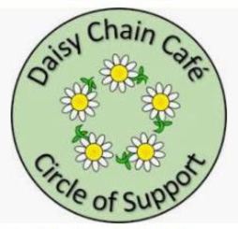
For people living with Dementia-Memory Loss
and their supporter
Daisy Chain Café
Darby Green Centre, Darby Green Road, Blackwater Yateley GU17 0DT
Every Monday 14.00 – 16.00
Except Bank Holidays

FREE TO ATTEND
The Café offers a relaxed, friendly place to exchange ideas with others in similar circumstances along with light refreshments, table activities, crafts, and occasional entertainment. A chance to make new friends and share the support of others.
Large Free Car Park
Stagecoach Bus 3 stops on Darby Green Road

New volunteers always welcome for further information find us on Facebook – Daisy Chain Café Yateley, email daisychaincafe1@gmail.com
Yateley Town Council 01252 872198
Donations welcomed directly or via EasyFundraising.org.uk

Registered Charity 1192818
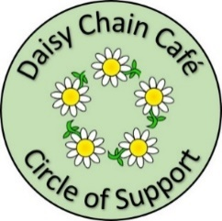
For people living with Dementia-Memory Loss
and their supporter
Daisy Chain Café
Darby Green Centre, Darby Green Road, Blackwater Yateley GU17 0DT
Every Monday 14.00 – 16.00
Except Bank Holidays

FREE TO ATTEND
The Café offers a relaxed, friendly place to exchange ideas with others in similar circumstances along with light refreshments, table activities, crafts, and occasional entertainment. A chance to make new friends and share the support of others.
Large Free Car Park
Stagecoach Bus 3 stops on Darby Green Road

New volunteers always welcome.
For further information find us on Facebook – Daisy Chain Café Yateley, email daisychaincafe1@gmail.com
Yateley Town Council 01252 872198
Donations welcomed directly or via EasyFundraising.org.uk

Registered Charity 1192818

